# **Set up a Microsoft 365 developer subscription**

Lab environment Setup guide

Published: 28 Mar, 2022

Table of Contents

Lab: Setting up your environment 2

# Lab: Setting up your environment

Exercise 1: Sign Up for a Microsoft 365 developer subscription

In this exercise, you will sign up for an Office 365 E5 Developer Subscription tenant for use during the workshop.

Set up a Microsoft 365 developer subscription to build your solutions independent of your production environment. The subscription is a Microsoft 365 E5 Developer subscription with 25 user licenses. It lasts for 90 days and is free to use for development purposes (coding solutions) only.

**Step 1**

1. Browse to <https://developer.microsoft.com/en-us/office/dev-program>
2. Click ‘Join Now’ Button

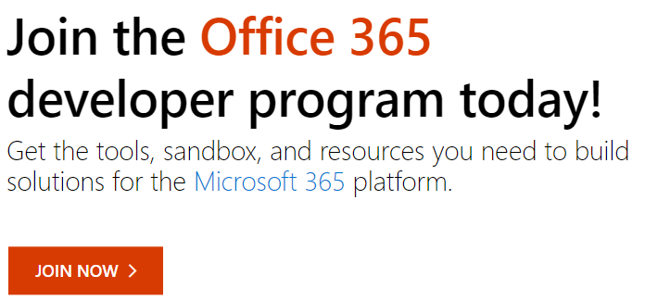

1. It will redirect to login page,
   1. If you have Microsoft account, please login using that and go to **Step :2**
   2. If not follow below steps to create one using your personal email ids.

Note: Don’t use official email ids.

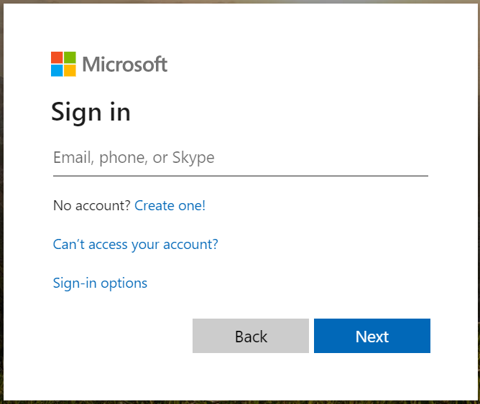

1. If you don’t have Microsoft account, Click Create one!

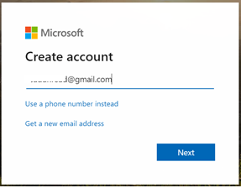

1. Enter your email ID and click Next

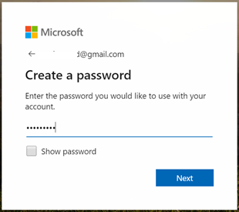

1. Enter your password and click Next.
2. It will send verify email with code.

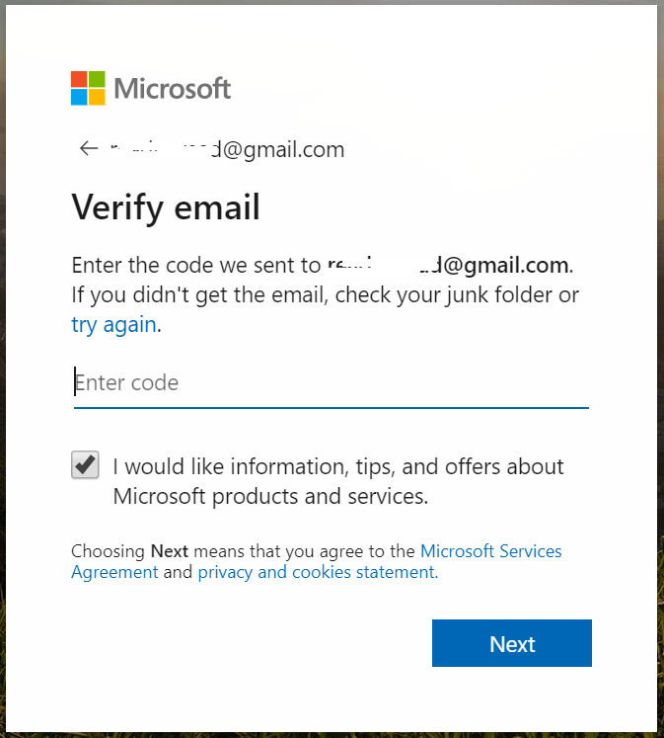

1. Enter the code received from your email and click Next

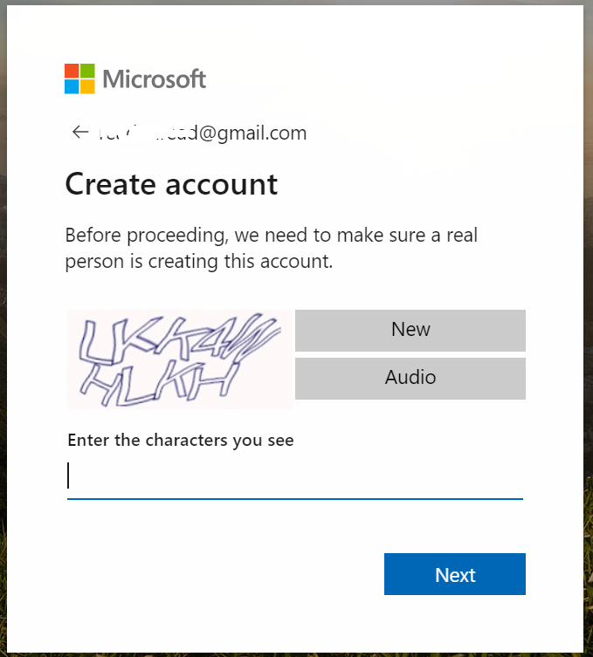

1. Please add your first and last name to your Microsoft Account at https://account.microsoft.com/profile. Otherwise it will throw error.

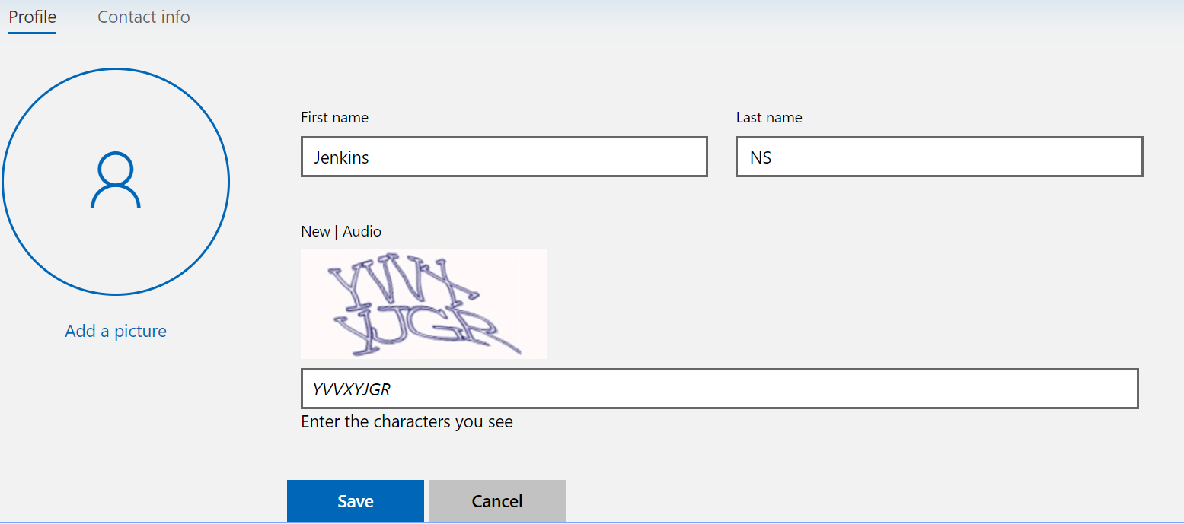

1. Click Save to save the profile
2. Sign-out and Close all Browsers

**Step: 2**

1. Open new browser and browse to <https://developer.microsoft.com/en-us/office/dev-program>
2. Click ‘Join now’ button



1. Sign in using Microsoft account

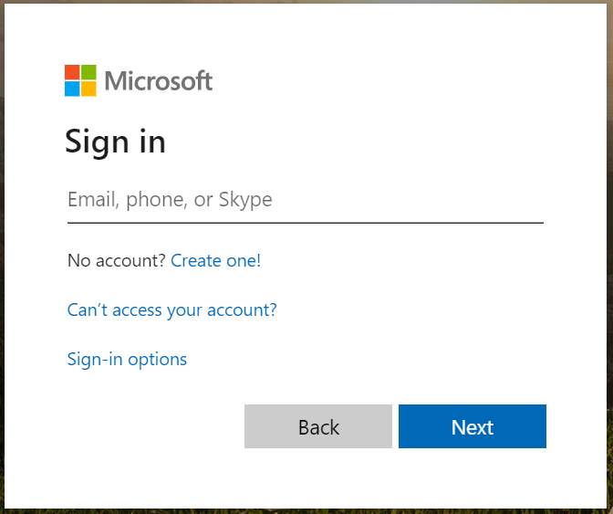

1. It will redirect to Office 365 Developer Program Signup
2. Enter ‘Country’ and ‘Company’
3. Then accept the terms and condition and click next.

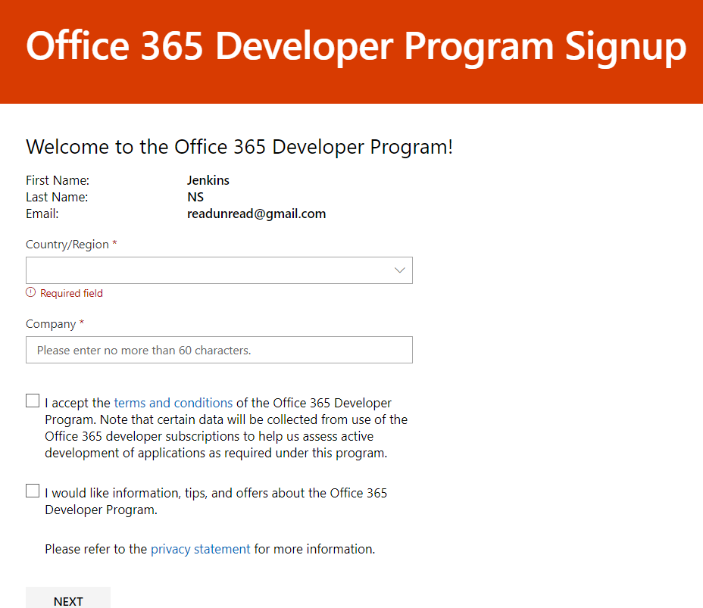

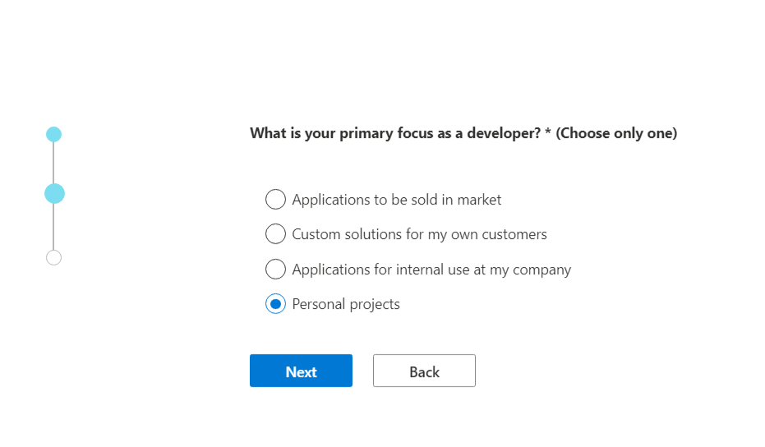

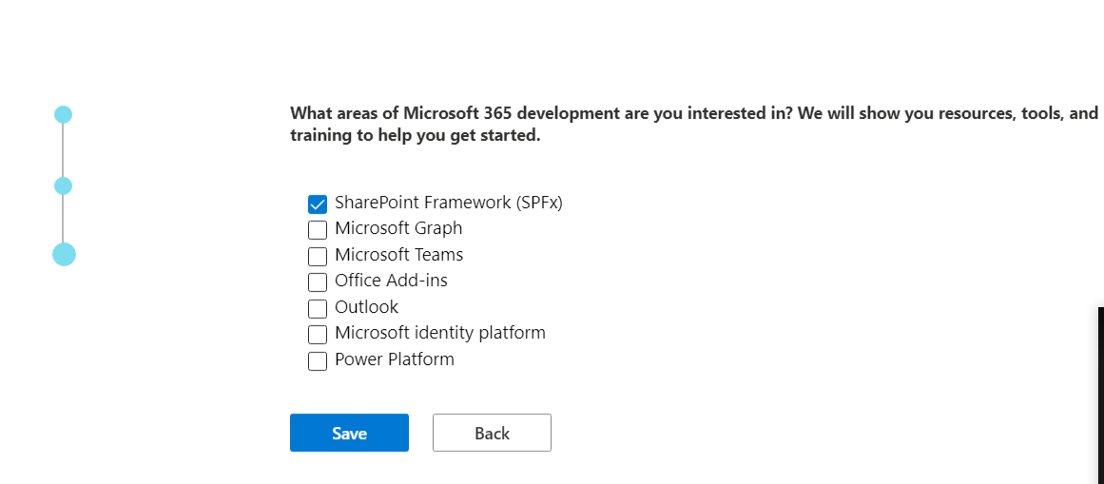

Save it

1. Then complete all columns and click ‘JOIN’ button to create Office 365 Developer Subscription.

Select Instant sandbox it

1. Click continue and it ask your mobile number to send OTP

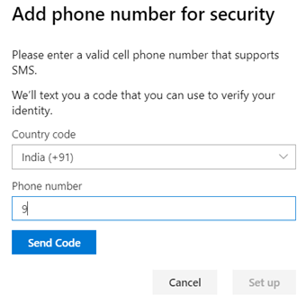

1. Click Send Code button
2. It will send an OTP to your mobile number
3. Then enter the code and click submit, it will create the subscription with admin credentials.

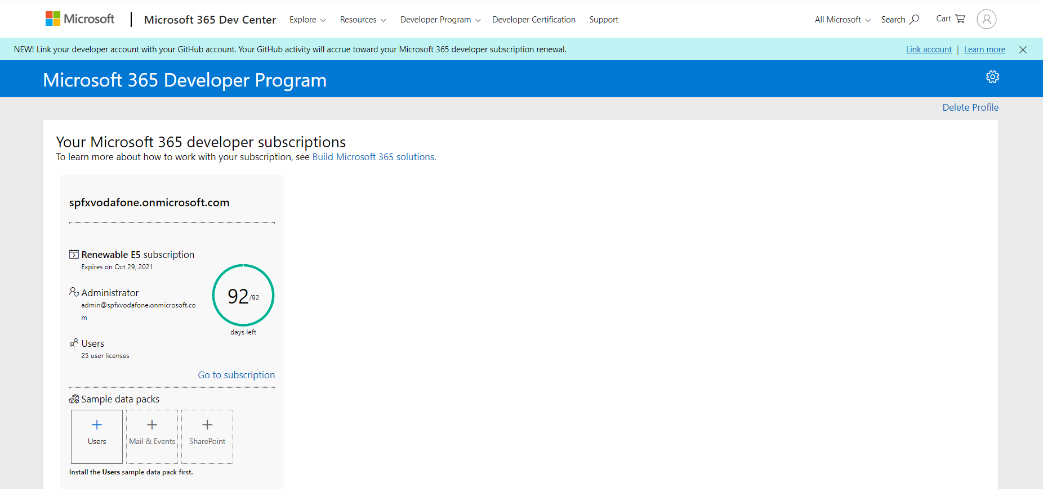

1. Logout from your personal email id
2. Login with your new office 365 tenant admin account **office.com**
3. **Example** admin@jenkinsnsfs.**onmicrosoft.com**
4. Now you created the Office 365 Developer subscription.